How to Make an Eternity Bracelet

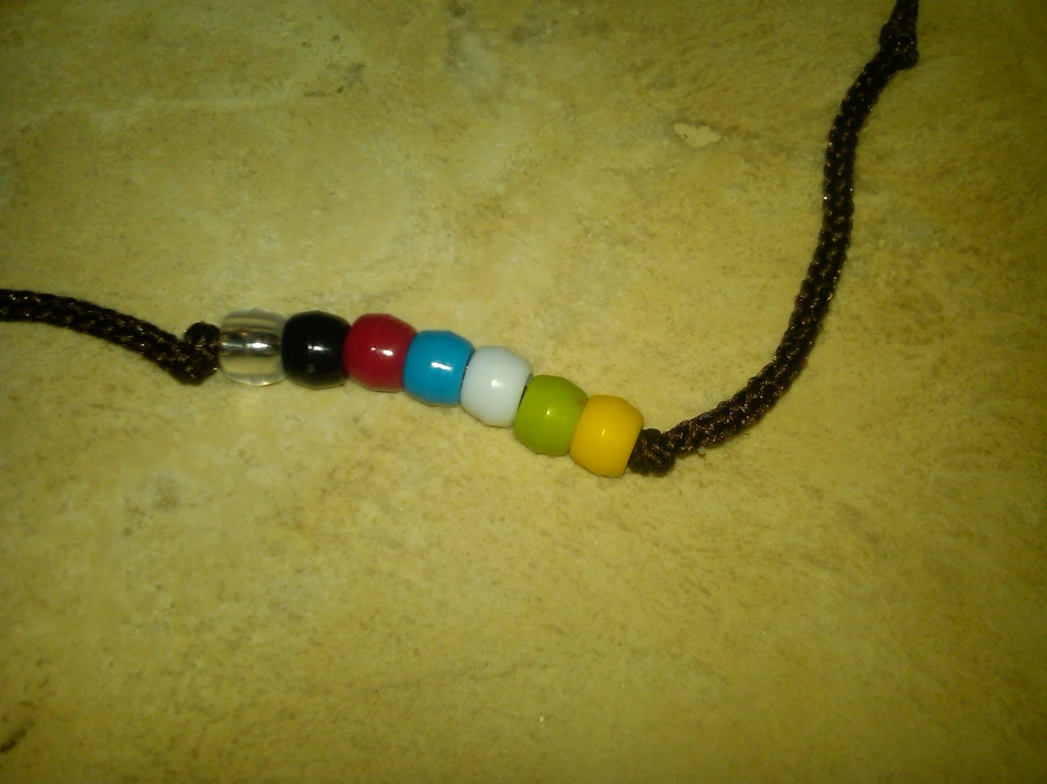

Materials required:
- Beads: Clear, Black, Red, Blue, White, Green, and Yellow
  - We purchase ours from Hobby Lobby. They come in a package of 360 beads for $2.99.
- Cord or string
  - We purchase ours at Hobby Lobby. We use crochet cord size 2 mm. It cost $3.99 for 100 yards. You may choose to use a different material for your bracelet string.
- Ruler to measure the cord.
- Scissors to cut the cord.
- Candle and lighter to singe the ends of the cord so that it does not unravel.

Step 1:
Cut the string in 12” lengths for the average person.
Cut the string in 14” lengths for people with a larger wrist.

Step 2:
Singe the ends of the cord by holding the end briefly in the candle flame. Be careful not create a melted ball on the end of the cord, because it will not fit through the hole in the bead. You may have to use your fingers to flatten out any build up on the end of the cord, while the end is still melted enough to mold.

Step 3:
Tie a slip knot on one end of the cord. Make sure the slip knot slides up and down the long part of the bracelet, instead of the short end of the slip knot. Try to place this knot as close to the end without using excess cord to tie the knot, such that, you don’t waste the cord and shorten the bracelet too small. The slip knot makes it easier to put the bracelet on and allows the bracelet to be sized and tightened, so that the bracelet does not fall off.

Step 4:
On the same end of the cord as the slip knot, tie another simple knot about 2” to 3” from the slip knot end. Do not tighten the knot too much, because this knot will be used to keep the beads from moving around on the bracelet.

Step 5:
String the 7 colored beads onto the cord in the following order: Clear, Black, Red, Blue, White, Green, and Yellow

Step 6:
After the beads have been strung, tie another simple knot on the other end of the beads. Try to wedge the beads between the two simple knots to keep the beads from moving around on the bracelet.

Step 7:
On the opposite end of the slip knot, tie one final simple knot. Again try not to tighten this knot too much, because it will be used to hold the bracelet on your wrist by looping through the hole of the slip knot. Also, try to place this knot as close to the end without using excess cord to tie the knot, such that, you don’t waste the cord and shorten the bracelet too small.

How to order the poem card that explains the bracelet:
- Go to GotPrint.com or call 1.877.922.7374
- For cards in English, reference order number: GP_3731770
- For cards in Spanish, reference order number: GP_3692136
  - Tell them that you want to order the same card, but put your Churches name, phone number, and website at the bottom of the card. The Spanish cards do not have a reference to a particular Church at the bottom. So, they can be ordered as is, with no changes.
  - When we placed our order, the cost was approximately $200 for 5,000 cards, if you order them as hand tags, which mean they have a small hole in the corner. Some people wanted these to hang them on their key chains, rear view mirrors, etc.
  - When we placed an order for the same size and quality of card, but as a business card instead of a hang tag, they were cheaper and we received our order faster.
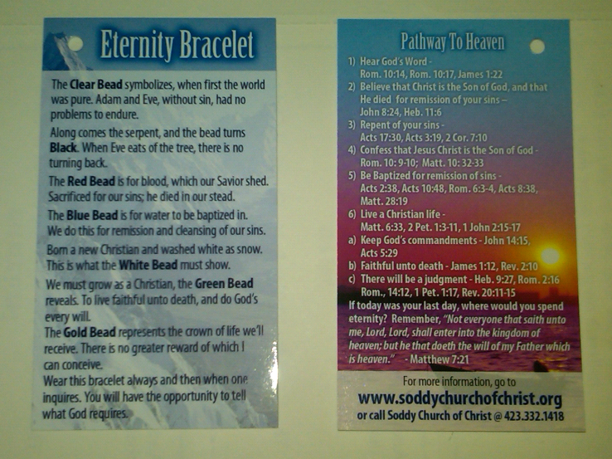

Approximate cost of one bracelet package:
Beads = (7 packages of beads x $2.99 per package) / 360 beads per package = $0.058
Cord = $3.99 per roll of cord / (100 yards per roll x 3 bracelets per yard) = $0.013
Card = $200 / 5,000 cards = $0.04
Ziplock snack bag for packaging = $2.50 for box / 100 snack bags in a box = $0.025
Total cost of one bracelet package = $0.13 (Say 15 cents to include taxes, etc.)

We are trying to track all the locations that the bracelets are sent on a world map. Please email us at www.soddychurchofchrist.org to let us know where all you are sending them. Also, please share your stories for encouragement. Thank you!

